Useful info

The link for the shock:

<https://www.ohlinsusa.com/suspension-products/ttx25-mkii?fbclid=IwAR1YzVUpfm5_al59p6GEEQVVAXq1qa_GwEuL5bgQWwImST9tF4VuchwxEZU>

C- compression, R- rebound

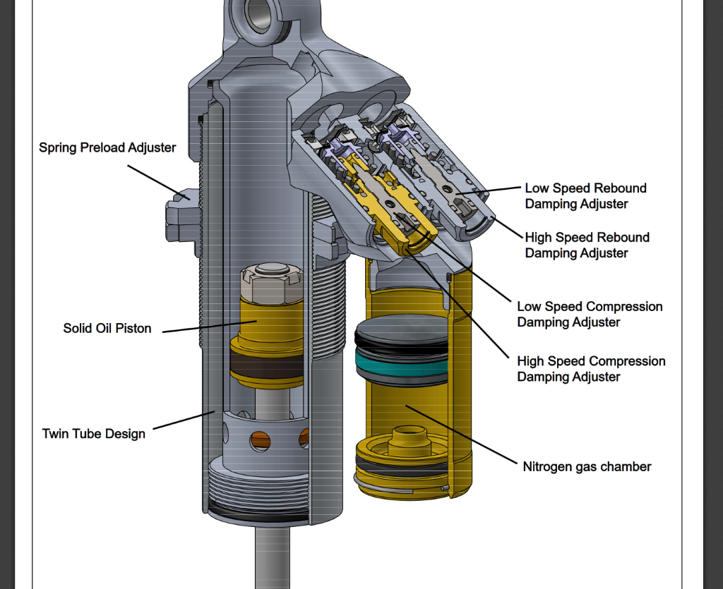

The number on the OEM graph corresponds to the number of turns the respective valve